**Software Requirements Specification**

**Version 2.0**

**Enemy Lines**

**Group B9**

|  |  |  |
| --- | --- | --- |
| **Member Name** | **Member Roll #** | **Primary Responsibility** |
| **Abdullah Siddiqui** | **L164158** | Functional Requirements tables |
| **Haider Nadeem** | **L164045** | Non-Functional Requirements |
| **Haad Fida** | **L164032** | Functional Requirements tables |
| **Asad Abrar** | **L164292** | Functional Requirements tables and Appendix B |
| **Zeenat Hassan** | **L164393** | Section 1 |

**Contents**

**1.** **Introduction 5**

1.1 Product 5

1.2 Scope 5

1.3 Business Goals 5

1.4 Document Conventions 5

1.5 References 6

**2.** **Functional Requirements 7**

2.1 Select Mission 7

2.2 Exit Game 8

2.3 Save Progress 9

2.4 Continue from Saved State 10

2.5 Information Display 11

2.6 Generate Map 12

2.7 Map Deletion 13

2.8 Move Player 14

2.9 Aim for Target 15

2.10 Shooting 16

2.11 Decrease Health 17

**3.** **Nonfunctional Requirements 18**

3.1 Performance Requirements 18

3.2 Security Requirements 18

3.3 Security requirements 18

3.4 Usability Goals………………………………………………………………………………….17

**4.** **Other Requirements 19**

4.1 Error handling 19

4.2 Legal 19

**Appendix B: Analysis Models 20**

**Appendix C: Design Models 2****4**

**Table of Figures**

Table 1: UC-1 6

Table 2: UC-2 7

Table 3: UC-3 8

Table 4: UC-4 9

Table 5: UC-5 10

Table 6: UC-6 11

Table 7: UC-7 12

Table 8: UC-8 13

Table 9: UC-9 14

Table 10: UC-10 15

Table 11: UC-11 16

Figure 1: Analysis Model

Figure 2: DFD 0 20

Figure 3: DFD 1 21

Figure 4: Class Diagram 22

Figure 5: Component Diagram 22

**Revision History**

|  |  |  |  |
| --- | --- | --- | --- |
| **Name(s)** | **Date** | **Reason(s) For Change(s)** | **Version** |
| Zeenat Haasan | 03-10-2019 | Business goals incorrect | 0.1 |
| Multiple Authors | 03-10-2019 | Refined document, edited out mistakes | 1.0 |
| Haad Fida | 28-10-2019 | Added component diagram for Appendix B | 1.1 |
| Abdullah Siddiqui | 01-11-2019 | Added DFD 0, corrected formatting | 1.3 |
| Zeenat Hassan | 04-11-2019 | Rectified mistakes done in Version 1.0 | 1.5 |
| Haider Nadeem Mirza | 09-11-2019 | Added DFD 1 for Appendix B | 1.8 |
| Asad Abrar | 09-11-2019 | Added class diagram, fixed formatting in document | 2.0 |

# Introduction

## Product

We intend to build a 2-D Top Down Shooter game based on **Second World War** theme. The aim of developing this game is to build a historically accurate game which can help in packaging history in an exciting manner. Our game is initially a 2-player Desktop application. Like, other shooter games it has different levels but it will be kept unique in a way that each level will be representing some event of Second World War. Since we intend to help people learn about the events of World War II more accurately, we will be presenting the information regarding the events including dates, main protagonists, places, how it took place and its impacts on the World through pop up boxes appearing at the start of each level. After completion of a level the winner will be declared and if the winner is opposite to as it was in the real event, again a pop-up box will appear showing information about the real results and actual triumphant.

## Scope

The major aim of developing this game **“Enemy Lines**” is to provide a platform for people to learn about history in an interactive and creative way. We will utilize the combined knowledge of Software Engineering and Game Development Concepts to create a product that promotes “fun learning”. Initially, we plan to keep it on a simple level covering only one historical site and that is the **Second World War**. It will be a Desktop application in the beginning. Our targeted audience will be anyone of age (12+), belonging to any gender who intends to learn about the events of World War II or simply wish to play a shooter game. If this leads to success, we will launch it on a higher level covering more historical sites and more versions of it. Including web-based and android version of game.

## Business Goals

The major business goal is to generate as much revenue as we can from this game. For this purpose, we have the following strategy:

* Initially, our game is a Desktop application covering only one historical site. So, in the beginning we will keep it a “free play version” for all. If it leads to success, we will introduce web-based and Android version of it covering more historical sites. And then the user would have to pay some price to upgrade to a premium version of the game with unrestricted access to all of its features.
* We will introduce our game at app store. So later on, if people intend to have access of the game, they need to purchase it from the app store.
* We might boost our game’s revenue through in-game advertisements such as rewarded ads, offer walls, interstitials, and playable ads.
* We will also try to generate money through in app purchases.

## Document Conventions

* **Enemy Lines** - Name of our game

## References

Some of the links used to understand the concept of top down shooter game are as follows:

●https://www.youtube.com/watch?v=cjh35bEZLLc

●https://www.google.com/search?q=top+down+shooter&client=ms-android-huawei&prmd=ivn&sxsrf=ACYBGNRdh1opYcAfW_0DVw-VGRfx4cQw4A:1568453412429&source=lnms&tbm=isch&sa=X&ved=2ahUKEwijkPqjgNDkAhUx-YUKHSL8CIsQ_AUoAXoECAwQAQ&biw=360&bih=524

●<https://en.wikipedia.org/wiki/Shoot_%27em_up>

# Functional Requirements

## Select Mission

|  |  |  |  |
| --- | --- | --- | --- |
| **Identifier** | | UC-1 | |
| **Purpose** | | User selects a mission | |
| **Priority** | | Low | |
| **Actors** | | User, System | |
| **Pre-conditions** | | User has played that mission before | |
| **Post-conditions** | | The user is able to play that mission | |
| **Typical Course of Action** | | | |
| **S#** | **Actor Action** | | **System Response** |
| **1** | The user opens the menu screen | | The system loads the menu screen |
| **2** | The user clicks on mission selection | | The system shows various missions that the user can be played |
| **3** | The user clicks on a mission | | The system loads the particular mission |
| **Alternate Course of Action** | | | |
| **S#** | **Actor Action** | | **System Response** |
| **1** | The user exits menu selection | | The system exits menu selection |
| **3** | The user cancels loading a mission | | The system does not load the mission |

**Table 1: UC-1**

## Exit Game

|  |  |  |  |
| --- | --- | --- | --- |
| **Identifier** | | UC-2 | |
| **Purpose** | | System shall allow a user to exit the game during a mission | |
| **Priority** | | Low | |
| **Actors** | | User, System | |
| **Pre-conditions** | | User has played that mission before | |
| **Post-conditions** | | The user is able to play that mission | |
| **Typical Course of Action** | | | |
| **S#** | **Actor Action** | | **System Response** |
| **1** | The user clicks on the options menu | | The system displays the option menu |
| **2** | The user clicks on exit mission | | The system displays a pop up that asks the user to confirm whether he wants to exit the mission |
| **3** | The user clicks on Yes as confirmation | | The system closes the mission and shows game menu |
| **Alternate Course of Action** | | | |
| **S#** | **Actor Action** | | **System Response** |
| **3** | The user clicks on No as confirmation | | The system doesn’t exit the mission and allows the user to resume it. |

**Table 2: UC-2**

## Save Progress

|  |  |  |  |
| --- | --- | --- | --- |
| **Identifier** | | **UC-3** | |
| **Purpose** | | Allows the user to save progress after completing a mission. | |
| **Priority** | | **High** | |
| **Actors** | | User, System | |
| **Pre-conditions** | | User must have completed the mission. | |
| **Post-conditions** | | User’s progress is saved, can exit game or play another mission. | |
| **Typical Course of Action** | | | |
| **S#** | **Actor Action** | | **System Response** |
| **1** | User clicks the save progress button after completing a mission. | | The system responds by saving the progress of the user. |
| **Alternate Course of Action** | | | |
| **S#** | **Actor Action** | | **System Response** |
| **3** | The user clicks cancel button. | | The system closes the save progress dialog box and shows the previous screen. |

**Table 3: UC-3**

## Continue from Saved State

|  |  |  |  |
| --- | --- | --- | --- |
| **Identifier** | | UC-4 | |
| **Purpose** | | System shall allow a user to continue from a saved game state | |
| **Priority** | | Medium | |
| **Actors** | | User, System | |
| **Pre-conditions** | | User has a saved game state | |
| **Post-conditions** | | The user is able to continue his playthrough from where he left off | |
| **Typical Course of Action** | | | |
| **S#** | **Actor Action** | | **System Response** |
| **1** | The user opens the menu screen | | The system loads the menu screen |
| **2** | The user clicks on continue | | The system loads the mission which corresponds which comes after the users last ended successful mission |
| **Alternate Course of Action** | | | |
| **S#** | **Actor Action** | | **System Response** |
| **1** | The user plays a previous mission and ends that mission | | The system removes the continue option to give him the option to select and play the later missions. |

**Table 4: UC-4**

## Information Display

|  |  |  |  |
| --- | --- | --- | --- |
| **Identifier** | | UC-5 | |
| **Purpose** | | Show history of the given mission | |
| **Priority** | | High | |
| **Actors** | | System | |
| **Pre-conditions** | | Mission Complete | |
| **Post-conditions** | | Move to main menu/mission selection | |
| **Typical Course of Action** | | | |
| **S#** | **Actor Action** | | **System Response** |
| **1** | User completes the mission. | | The System shows some facts regarding that mission. |
| **Alternate Course of Action** | | | |
| **S#** | **Actor Action** | | **System Response** |
| **1** | User fails the mission. | | System shows facts about how events really turned out to be in real life |

**Table 5: UC-5**

## Generate Map

|  |  |  |  |
| --- | --- | --- | --- |
| **Identifier** | | UC-6 | |
| **Purpose** | | Generate map for the game | |
| **Priority** | | Medium | |
| **Actors** | | User, System | |
| **Pre-conditions** | | User loads a mission/ Continues the save | |
| **Post-conditions** | | The user is able to traverse the map and play the game. | |
| **Typical Course of Action** | | | |
| **S#** | **Actor Action** | | **System Response** |
| **1** | The user clicks continue/load mission. | | The system starts the process of map generation |
| **2** | The system requests to generate terrain | | The system shall allow the presence of terrain |
| **3** | The system requests to generate different objects. | | The system shall allow the presence of various objects |
| **Alternate Course of Action** | | | |
| **S#** | **Actor Action** | | **System Response** |
| **1** | The system fails to generate terrain due as memory is full | | The system shows an error message and forcefully exits the application |
| **2** | The system fails to generate trees and terrain as they are invisible | | The system shows the objects are a delay as it loads them |

**Table 6: UC-6**

## Map Deletion

|  |  |  |  |
| --- | --- | --- | --- |
| **Identifier** | | UC-7 | |
| **Purpose** | | Deletion of map | |
| **Priority** | | Medium | |
| **Actors** | | User, System | |
| **Pre-conditions** | | User exits the game. | |
| **Post-conditions** | | The system deallocates all memory used in map generation. | |
| **Typical Course of Action** | | | |
| **S#** | **Actor Action** | | **System Response** |
| **1** | The user clicks to exit the game | | The system starts the process of destroying the map created |
| **2** | The system requests to destroy terrain | | The system shall allow the destruction of terrain |
| **3** | The system requests to destroy different objects | | The system shall allow the destruction of various objects |
| **Alternate Course of Action** | | | |
| **S#** | **Actor Action** | | **System Response** |
| **1** | The system requests to destroy terrain | | The system responds that the terrain is already deleted |
| **2** | The system requests to destroy different objects | | The system responds that the different objects are deleted |

**Table 7: UC-7**

## Move Player

|  |  |  |  |
| --- | --- | --- | --- |
| **Identifier** | | UC-8 | |
| **Purpose** | | Allows a user to move the player along x-axis and y-axis. | |
| **Priority** | | **High** | |
| **Actors** | | User, System | |
| **Pre-conditions** | | User must have started/loaded the game, keyboard must be connected. | |
| **Post-conditions** | | … | |
| **Typical Course of Action** | | | |
| **S#** | **Actor Action** | | **System Response** |
| **1** | The user presses specific keys (W, A, S and D) to move. | | The system responds by moving the player in the specified direction. |
| **Alternate Course of Action** | | | |
| **S#** | **Actor Action** | | **System Response** |
| **1** | The user presses specific keys (W, A, S and D) to move. | | The system responds by not moving the player because it is on the boundary of the map. |
| **1** | The user presses other keys. | | The system responds by doing nothing. |

**Table 8: UC-8**

## Aim for Target

|  |  |  |
| --- | --- | --- |
| **Identifier** | UC-9 | |
| **Purpose** | Allows the user to aim the cursor at any (x, y) position in the playable-map area. | |
| **Priority** | **High** | |
| **Actors** | User, System | |
| **Pre-conditions** | User must have loaded/started the game, mouse must be connected. | |
| **Post-conditions** | **…** | |
| **Typical Course of Action** | | |
| **S#** | **Actor Action** | **System Response** |
| **1** | User moves the mouse to (x, y) position in the playable area. | The system moves the crosshair/cursor to that (x, y) position. |
| **Alternate Course of Action** | | |
| **S#** | **Actor Action** | **System Response** |
| **1** | User moves the mouse to (x, y) position in the non-playable area. | The system responds by maintaining the crosshair/cursor at the last position in the playable area visited by the user. |

**Table 9: UC-9**

## Shooting

|  |  |  |  |
| --- | --- | --- | --- |
| **Identifier** | | UC-10 | |
| **Purpose** | | Allows the user to shoot at the (x, y) position currently cursor is at in the playable area. | |
| **Priority** | | **High** | |
| **Actors** | | User, System | |
| **Pre-conditions** | | User must have loaded/started the game, mouse and keyboard must be connected. | |
| **Post-conditions** | | **…** | |
| **Typical Course of Action** | | | |
| **S#** | **Actor Action** | | **System Response** |
| **1** | User presses the shoot button on their keyboard. | | The system responds by showing bullets being shot towards the position targeted by the cursor. |
| **Alternate Course of Action** | | | |
| **S#** | **Actor Action** | | **System Response** |
| **1** | User presses the shoot button on their keyboard while the cursor is out of bounds of the playable area. | | The system responds by showing bullets being shot towards the nearest position (in the line of fire) in the playable area. |

**Table 10: UC-10**

## Decrease Health

|  |  |  |  |
| --- | --- | --- | --- |
| **Identifier** | | UC-11 | |
| **Purpose** | | Reduce health of player or kill player when hit by a bullet | |
| **Priority** | | High | |
| **Actors** | | User, System | |
| **Pre-conditions** | | User’s aim set on enemy. | |
| **Post-conditions** | | Reduced health status of player. | |
| **Typical Course of Action** | | | |
| **S#** | **Actor Action** | | **System Response** |
| **1** | The user clicks to fire bullet in aim direction. | | Player health reduced. |
| **Alternate Course of Action** | | | |
| **S#** | **Actor Action** | | **System Response** |
| **1** | The user misses the enemy. | | Player health remains same. |
| **Alternate Course of Action** | | | |
| **S#** | **Actor Action** | | **System Response** |
| **1** | Player health reduced to 0. | | Player defeated. Game lost. |

**Table 11: UC-11**

# Nonfunctional Requirements

## Performance Requirements

* Bullets should be fired in less than 1 second after a mouse click.
* Damage caused by any ammunition hitting the enemy shall show decrease in health in less than 1 second.
* Level selected by player should be ready to play in less than 5 seconds.
* If user fails to complete a level, pop up asking to play again or quit should come up in less than 3 second.

## System Requirements

* The game should run on windows 10

## Security requirements

* The game shall not ask any personal questions that could create data privacy issues.
* The game shall have no social media integration.
* The game shall have no online functionality.

* 1. **Usability goals**
* The main menu shall have a clean interface with minimal art work and buttons
* There will be icons next to each button to help user quickly identify what each button does
* The user shall require no prerequisite training to navigate the game

# Other Requirements

**4.1 Error handling**

* Any software bugs or errors shall be handled gracefully to ensure a stable experience

**4.2 Legal**

* All art, sound and intellectual property used in the game shall either be royalty free or self-made, there will be no infringement of any copyrights

# Appendix B: Analysis Models

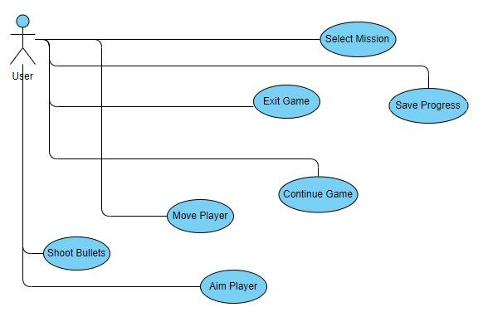

**Figure 1: Analysis Model**

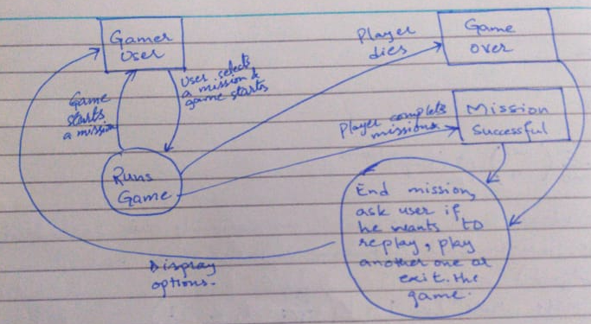

**Figure 2: DFD 0**

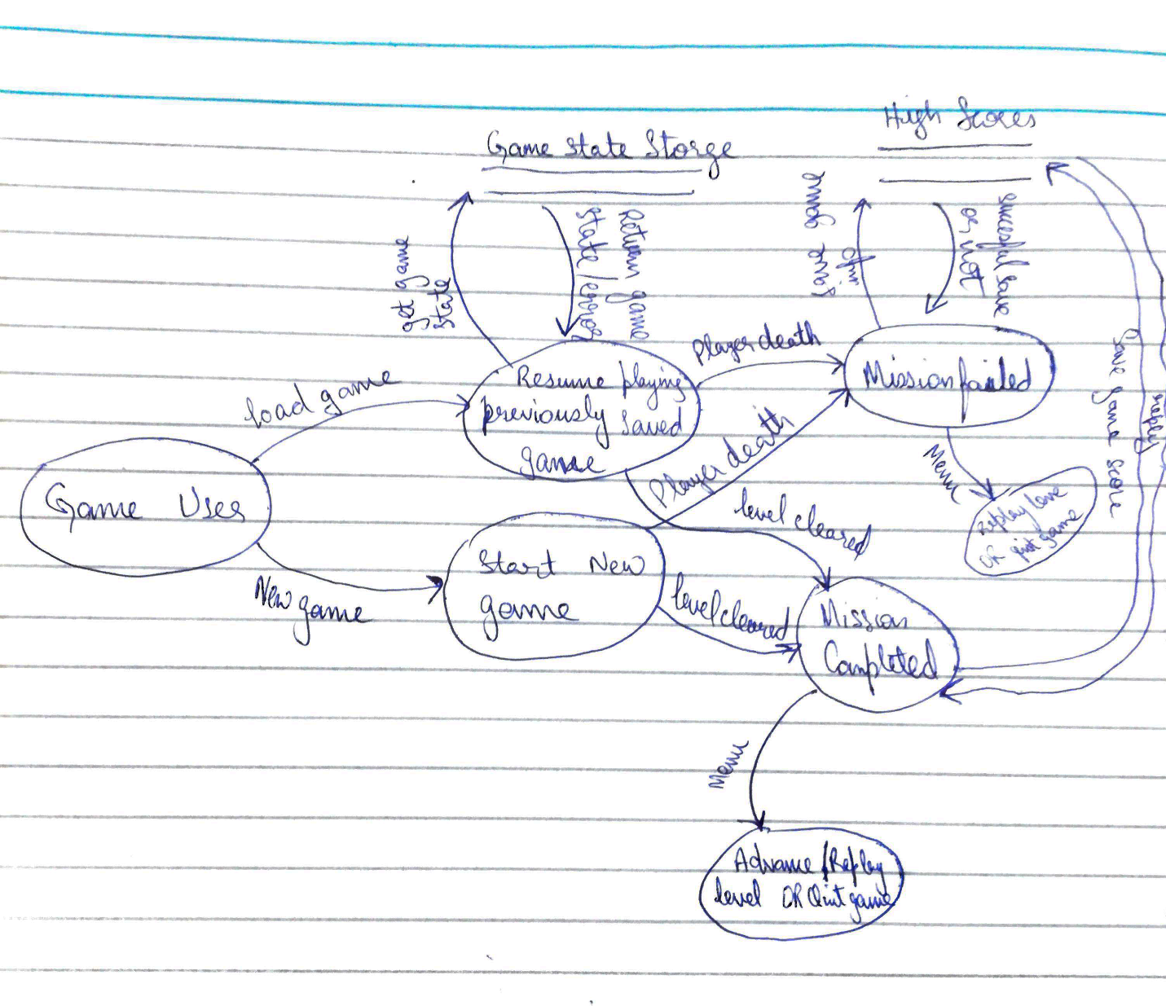**Figure 3: DFD 1**

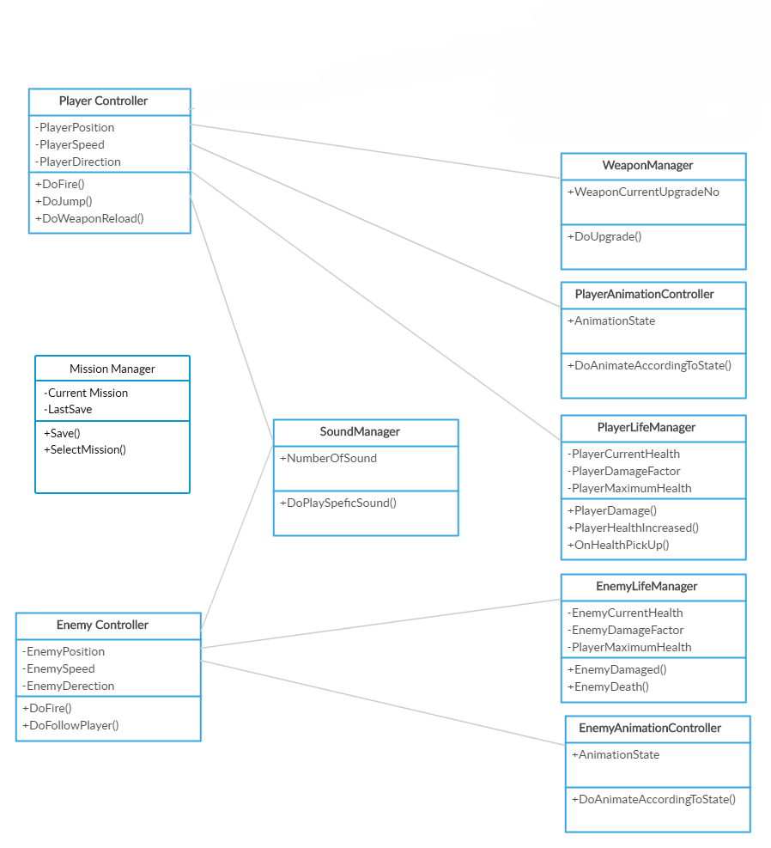 **Figure 4: Class Diagram**

**Appendix C: Design Models**

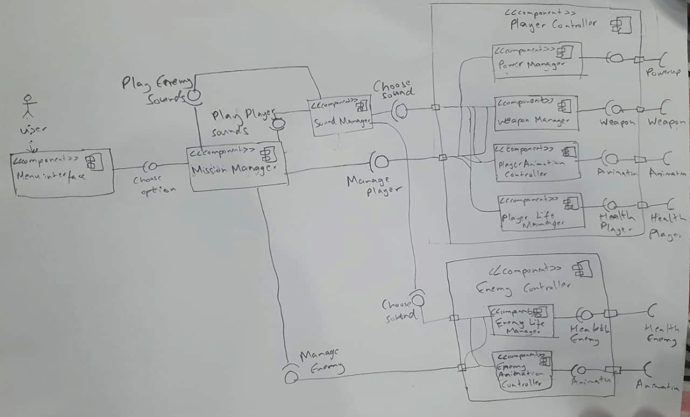**Figure 5: Component Diagram**